Pat McCrory, Governor John E. Skvarla, III, Secretary
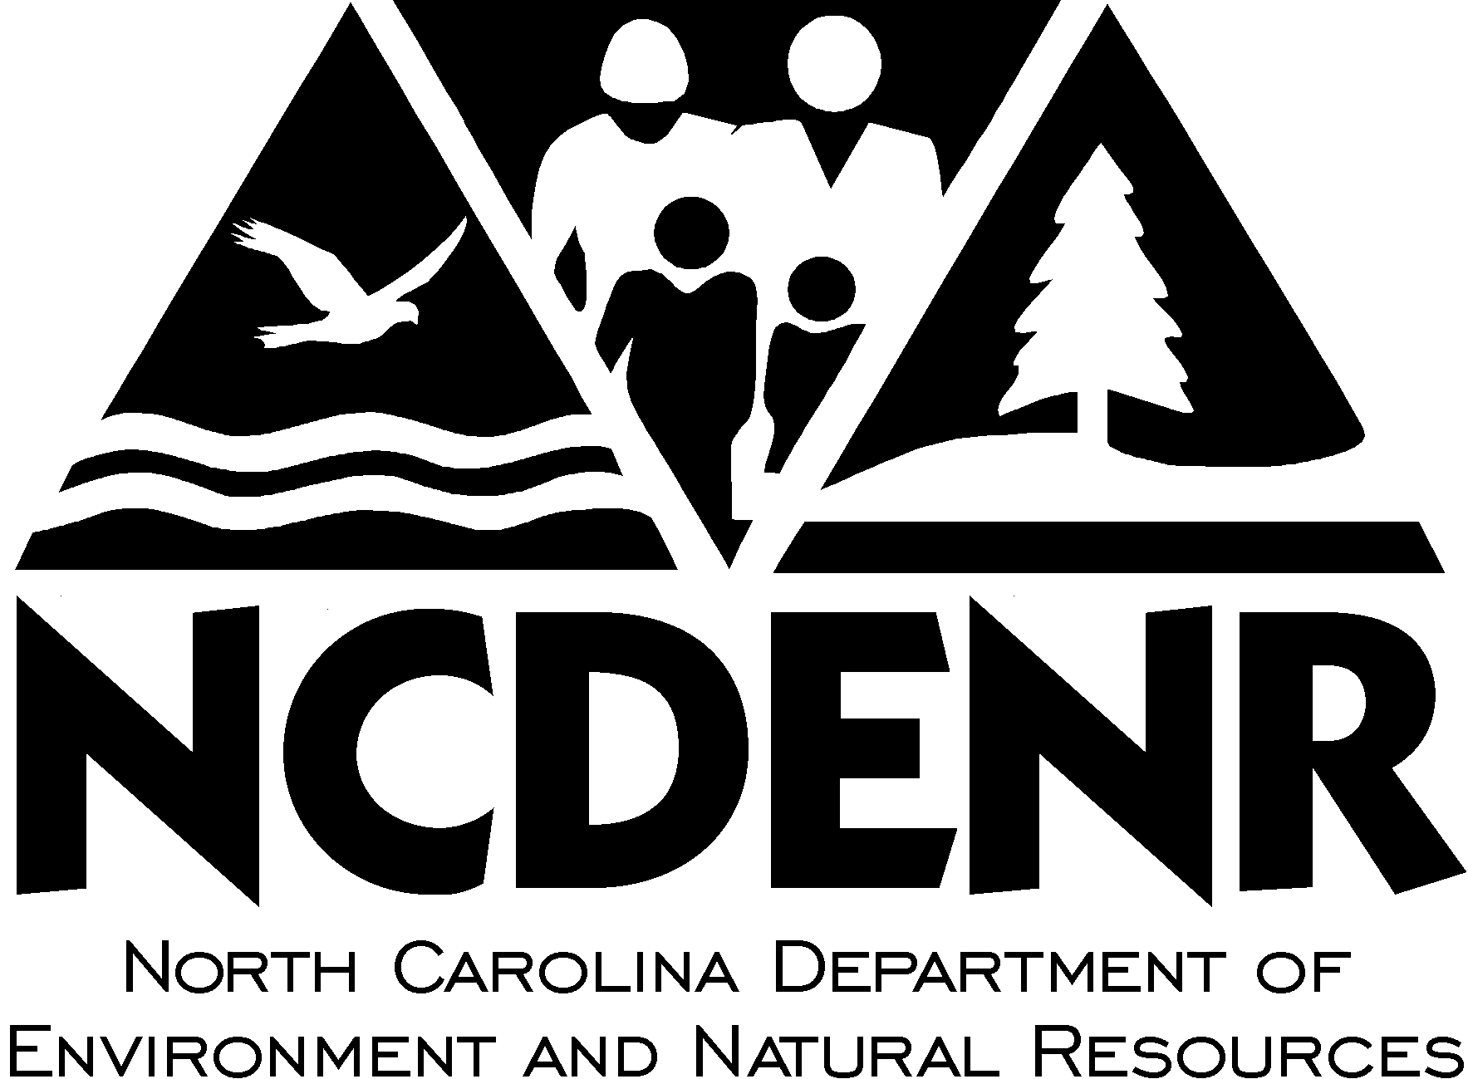

N.C. Department of Environment and Natural Resources

Release: Immediate Contact: Charlie Peek
Date: Jan. 7. 2014 Phone: 919-218-4622

State park deer relocation project will benefit Eastern Band of Cherokee Indians

RALEIGH – Morrow Mountain State Park will participate in a long-term project to relocate white-tailed deer from the park to reservation lands of the Eastern Band of Cherokee Indians, according to the N.C. Division of Parks and Recreation.

Partners in the initiative are the state parks system, the N.C. Wildlife Resources Commission, biologists from Great Smoky Mountains National Park and the Cherokee Fisheries and Wildlife Management program.

The agencies intend to augment the reservation’s sparse population of white-tailed deer, an animal that figures prominently in Cherokee lore and cultural traditions. The deer will be gradually released onto the 56,000-acre Qualla Boundary, in habitat improved for browsing and currently off-limits to hunting.

In each of the next three years, between 25 and 50 deer will be relocated, primarily females in small family groups. Initial collections will begin in January, with biologists using darts to tranquilize the animals, collecting data on age and health, and fitting each with a tag and radio collar. The deer will be kept in a large pen on the reservation and closely monitored for about four weeks before being released.

“We’re pleased that the state park can fulfill this request for white-tailed deer on the Cherokee reservation in a way that’s consistent with wise natural resource management, “ said Carol Tingley, acting director for the N.C. Division of Parks and Recreation. “Morrow Mountain State Park sustains an abundance of healthy native deer that can readily be identified and collected.”

A 2013 herd health study by the state park and the Wildlife Resources Commission suggests that such a project will benefit the remaining herd and habitat at Morrow Mountain in Stanly County. The relocation project will be carried out under specialized scientific protocols developed by the wildlife agency.

“Environmental protection of the Natural Resources of the Eastern Band of Cherokee Indians has been paramount for my administration,” Cherokee Principal Chief Michell Hicks said. “The Cherokee Fisheries and Wildlife Management program has worked to protect those resources and has worked to restore native species to the region. The white-tailed deer restoration continues this important tribal work and demonstrates the tribe’s commitment to work with the North Carolina Department of Environment and Natural Resources in collaboration. These efforts will have lasting effects on our tribal community and on the region.”

A byproduct of the relocation project will be a unique research opportunity that can offer insight into white-tailed deer health and best practices for rebuilding and sustaining healthy herds. This type of information will benefit wildlife management agencies as well as private, nonprofit groups involved in deer rehabilitation.

###

